Hongri (Richard) Gu
Division of Integrated System and Design,
Hong Kong University of Science and Technology (HKUST)
Tel. : +852-56489193; E-mail: hongrigu@ust.hk; Homepage: https://guhongri.com/
ORCID: 0000-0002-6396-3408
Google Scholar: https://scholar.google.com/citations?user=CkSbyu8AAAAJ&hl=en
Research Gate: https://www.researchgate.net/profile/Hongri_Gu

EDUCATION
Ph.D. in Mechanical Engineering, 01.2017-12.2021, ETH Zurich, Switzerland
Thesis: “Soft Intelligent Structures with Complex Magnetizations” (defense date: 26 Oct. 2021)
Advisor: Prof. Brad Nelson
M.Sc. in Micro and Nanosystems, 09.2014-11.2016, ETH Zurich, Switzerland
Advisor: Prof. Brad Nelson
Academic Cooperation Agreement Program, 02.2014-08.2014, Tokyo Institute of Technology, Japan
Young Scientist Exchange Program, 09.2012-08.2013, Tokyo Institute of Technology, Japan
Advisor: Prof. Shinichi Yokota
B.Eng. in Mechatronics Engineering, 09.2009-06.2014, Zhejiang University, China

Employment History
01.2025-now Tenure Track Assistant Professor, Division of Integrative System and Design, Hong Kong University of Science and Technology, Hong Kong SAR
01.2022-12.2024 Postdoctoral Associate, University of Konstanz, Germany
(Advisor: Prof. Clemens Bechinger)
01.2017-12.2021 Scientific Assistant, Multi-Scale Robotics Lab, ETH Zurich, Switzerland
02.2014-08.2014 Research Assistant, Tokyo Institute of Technology, Japan

AWARDS AND RECOGNITIONS
05.2024 CASCB Travel Grant, (3k EUR), Centre for the Advanced Study of Collective Behaviour
05.2023 Best Poster Award for ICRA 2023 workshop: “Shrinking the Cutting Edge, Making Small-Scale Medical Robots for Humans”, IEEE Robotics and Automation Society
11.2022 ETH Medal for outstanding doctoral thesis 2022, (2k CHF), ETH Zurich
10.2022 Best Talk Award for microTAS 2022 (runner up), (500 USD), Chemical and Biological Microsystems Society (CBMS) (>800 participants)
07.2021 Chinese government award for outstanding self-financed students abroad of 2020, (6k USD), China Scholarship Council
2020 Top 50 Physics Articles, Nature Communications
2011-2012 Yilida-Liuyongling Scholarship, (5k CNY), Elite Machinery Holdings Ltd. (1/323)
07.2012 1st prize, 5th National Undergraduate Mechanical Innovation Design Competition, Ministry of Education of P. R. China (Top 2%)
05.2012 1st prize, 9th Mechanical Design Competition in Zhejiang Province, Zhejiang Undergraduate Science and Technology Society (ranked 1st/270)
04.2012 1st prize, Mechanical Design Competition of Zhejiang University, Zhejiang University
05.2011 3rd prize, 8th “Zhou-Peiyuan” National Mechanics Competition, Chinese Society of Theoretical and Applied Mechanics, May 2011 (Top 5%)
05.2011 1st prize, Mechanics Tournament of Zhejiang Province, Zhejiang Provincial Society of Theoretical and Applied Mechanics
2011-2012 1st prize, Research and Innovation Scholarship, Zhejiang University
& 2010-2011
2010 3rd Prize, Undergraduate Physics Tournament in Zhejiang Province, Zhejiang Physical Society

FELLOWSHIPS and RESEARCH GRANTS
01.2026-12.2028 Early Career Scheme (ECS), (722k HKD), Hong Kong Research Grants Council (RGC), “Wearable Electromagnetic Actuation Systems with Customized Force Output” (Grant number: 26217625)
09.2024-08.2028 Ambizione, (885k CHF), Swiss National Science Foundation, “Wearable
Electromagnetic Actuation Systems with Customized Force Output” (declined after taking HKUST offer)
01.2022-12.2023 Postdoc. Mobility Fellowship, (96k CHF), Swiss National Science Foundation, topic: “Soft Robots Powered by Active Matter” ( project number203203)
10.2012-08.2013 JASSO Fellowship, (960k JPY), Japan Student Service Organization, topic: “miniaturized electro-conjugate fluid micropumps”

PUBLICATIONS
Journal Articles
Hongri Gu*, Jose Hughes, Robert Baines, Clemens Bechinger, Bradley Nelson, “Ultraslow robotics and its applications”, (under preparation)
Huayang Sai, Yiyang Tang, Huiling Duan, Hongri Gu, Tian-Yun Huang*, “Ultrasound-powered microgear transmission”, (under review)

Hongri Gu*, Anton Lüders*, Clemens Bechinger*, “Nonmonotonic Magnetic Friction from Collective Rotor Dynamics”, Nature Materials, (2026)
Link: https://www.nature.com/articles/s41563-026-02538-1
Yanmei Ma, Weikang Hu, Muyang Ruan, Feixiang Bao, Xingguo Liu, Dong Sun, Hongri Gu*, and Chengzhi Hu*, “Label-free robotic mitochondrial biopsy”, Science Advances, 11, eadx4289 (2025).
Link: https://www.science.org/doi/10.1126/sciadv.adx4289
Yanmei Ma, Xinhao Li, Weikang Hu, Muyang Ruan, Ming Yang, Lingqian Chang, Hongri Gu, Chengzhi Hu “Development of electrochemical nanoprobe for real-time intracellular measurements of Fe2+ during ferroptosis”, Microsystems & Nanoengineering 11(1), 134 (2025)
Gerhard Gompper, Howard Stone, et al., “The 2025 Motile Active Matter Roadmap”, Journal of Physics: Condensed Matter 37, 143501 (2025)
Veit-Lorenz Heuthe, Emanuele Panizon, Hongri Gu*, Clemens Bechinger*, “Counterfactual reward enables collective transport using individually controlled swarm microrobots”, Science Robotics, 9,97 (2024): eado5888
Link: https://www.science.org/doi/10.1126/scirobotics.ado5888
Xiaoli He, Hongri Gu, Yanmei Ma, Yuhang Cai, Huaide Jiang, Yi Zhang, Hanhan Xie, Ming Yang, Liang Guo, Zhan Yang, and Chengzhi Hu, “Light-Patterning Semiconductor Nanoparticles by Modulating Surface Charges”, Nature Communications 15, 9843 (2024)
Hongri Gu*, Yonglin Chen, Anton Lüders, Thibaud Bertrand, Emre Hanedan, Peter Nielaba, Clemens Bechinger, and Bradley J. Nelson, “Scalable high-throughput microfluidic separation of magnetic microparticles”, Device, 100403 (2024)
Hao jiang, Hongri Gu, Bradley J. Nelson, Teng Zhang*, “Numerical Study of Metachronal Wave Modulated Locomotion in Magnetic Cilia Carpets”, Advanced Intelligent Systems, 202300212 (2023).
Hongri Gu*, Marino Möckli, Claas Ehmke, Minsoo Kim*, Matthias Wieland, Simon Moser, Clemens Bechinger, Quentin Boehler*, Bradley J. Nelson*, “Self-folding soft robotic chains with reconfigurable shapes and functionalities”, Nature Communications 14, 1263 (2023).
Link: https://www.nature.com/articles/s41467-023-36819-z
Bradley J. Nelson*, Pierre Dupont, Dario Floreano, Ken Goldberg, Hongri Gu, Neil Jacobstein, Cecilia Laschi, Hod Lipson, “What we look for at Science Robotics” (editorial), Science Robotics 7, no. 71 (2022).
Hongri Gu*, Emre Hanedan, Quentin Boehler, Tian-Yun Huang, Arnold J. T. M. Mathijssen*, Bradley J. Nelson*, “Artificial microtubules for fast and collective transport of magnetic microcargos”, Nature Machine Intelligence, 4, 678–684 (2022).
Link: https://www.nature.com/articles/s42256-022-00510-7
Tianyun Huang*, Hongri Gu*, Bradley J. Nelson*. “Increasingly intelligent micromachines” (review) Annual Review of Control, Robotics, and Autonomous Systems, 5 (2022).
Hongri Gu, Thibaud Bertrand, Quentin Boehler, Christophe Chautems, Nikolay V. Vasilyev*, Bradley J. Nelson*. “Magnetically Active Cardiac Patches as an Untethered, Non‐Blood Contacting Ventricular Assist Device” Advanced Science, 2000726 (2020).
Hongri Gu, Quentin Boehler, Haoyang Cui, Eleonora Secchi, Giovanni Savorana, Carmela De Marco, Simone Gervasoni, Quentin Peyron, Tian-Yun Huang, Salvador Pane, Ann M. Hirt, Daniel Ahmed, Bradley J. Nelson*. “Magnetic Cilia Carpets with Programmable Metachronal Waves” Nature Communications 11, 2637 (2020).
Link: https://www.nature.com/articles/s41467-020-16458-4
Pengfei Liu, Simone Gervasoni, Claudio Madonna, Hongri Gu, Andrea Coppo, Salvador Pané, Ann M Hirt*. “Response of remanent magnetization to deformation in geological processes using 3D-printed structures” Earth and Planetary Science Letters, 539 (2020): 116241.
Jizhai Cui*, Tian-Yun Huang*, Zhaochu Luo, Paolo Testa, Hongri Gu, Xiang-Zhong Chen, Bradley J. Nelson, and Laura J. Heyderman. “Nanomagnetic encoding of shape-morphing micromachines.” Nature 575, no. 7781 (2019): 164-168.
Hongri Gu, Quentin Boehler, Daniel Ahmed, and Bradley J. Nelson*. “Magnetic quadrupole assemblies with arbitrary shapes and magnetizations” Science Robotics 4, no. 35 (2019).
Link: https://www.science.org/doi/full/10.1126/scirobotics.aax8977
Dong Han*, Hongri Gu*, Joon-wan Kim*, and Shinichi Yokota*. “A bioinspired 3D-printed hybrid finger with integrated ECF (electro-conjugate fluid) micropumps.” Sensors and Actuators A: Physical 257 (2017): 47-57.

Conference Proceedings
Laura Pruszko, Hongri Gu, Julien Bourgeois, Yann Laurillau, Céline Coutrix, “Modular Tangible User Interfaces: Impact of Module Shape and Bonding Strength on Interaction”, TEI 2023, Warsaw, Poland, February 2023
Dong Han, Hongri Gu, Joon-wan Kim, Shinichi Yokota, Kazuya Edamura, “A Novel 3D-Printed Finger Integrated with ECF Micropump”, the 6th International Conference on Manufacturing, Machine Design and Tribology (ICMDT), Okinawa, Japan, April 2015
Hongri Gu, Joon-wan Kim, Shinichi Yokota, Kazuya Edamura, “3 Triangular Prism Electrodes Design for Electro-Conjugate Fluid Micropump”, 9th JFPS International Symposium on Fluid Power (JFPS), Matsue, Japan, 2014
Hongri Gu, Joon-wan Kim, Shinichi Yokota, Kazuya Edamura, “ECF Micropump by Using the triangular prism electrode and tapered slit electrode pairs”(in Japanese), JSME Conference of Machine Design and Tribology, Nagano, Japan, 2014
Hongri Gu, Joon-wan Kim, Shinichi Yokota, Kazuya Edamura, "Study on Output Characteristics of downsized ECF micropump", International Conference on Mechatronics Technology (ICMT), Jeju Island, Korea, 2013
Hongri Gu, Joon-wan Kim, Shinichi Yokota, Kazuya Edamura, "Study on ECF effect by miniaturizing electrodes pairs"(in Japanese), 2013 Annual Conference of Japanese Society of Mechanical Engineering, Okayama, Japan, 2013

Invited talk and CONFERENCE PRESENTATIONS
“Counterfactual reward enables collective transport using individually controlled swarm microrobots”, ICRA 2024 workshop: “Breaking Swarm Stereotypes”, Yokohama, 17 May 2024
“Self-folding soft-robotic chains with reconfigurable shapes and functionalities”, ICRA 2023 workshop: “Shrinking the Cutting Edge, Making Small-Scale Medical Robots for Humans”, London, 29 May, 2023 (Best Poster)
“Self-folding soft-robotic chains for minimally invasive surgeries”, RoboSoft 2023 workshop: “When Soft Robots get Small: Current Trends and New Perspectives in the Fabrication, Design and Application of Small-Scale Soft Robots”, Singapore, 3 April, 2023
“Fast and Robust Transport of Magnetic Microparticles on Artificial Microtubules”, µTAS 2022, Hangzhou, 23-27 October, 2022 (Best Talk)
“Soft robots powered by magnetically driven active particles”, DPG Meeting of the Condensed Matter Section, Regensburg, 5-9 September, 2022
“Artificial Microtubules for Rapid and Collective Transport of Magnetic Microcargoes”, Max Bergmann Symposium 2022, Dresden, 9-10 June, 2022
“Soft robotic structures with complex magnetizations”, Engineering and Applied Science Forum (for Ph.D., Postdoc, and Young faculty), 13 December, 2020
“Artificial Magnetic Cilia Carpets with Programmable Metachronal Waves”, Microswimmers International Conference 2020 “Motile Active Matter” (online), oral presentation, 29 October, 2020
“Magnetic Quadrupole Assemblies with Arbitrary Shapes and Magnetizations”, MaP Graduate Symposium 2020 (online), poster presentation, 1-2 July, 2020
“Artificial Magnetic Cilia Carpets with Programmable Metachronal Waves”, International conference on magnetic fluid (ICMF 2019), oral presentation, Paris, 9 July, 2019
“Complex Pumping by close-packing the active magnetic particles in fluidic networks”, Applied Mathematics Seminar, University of York, 28 April, 2017
“Design and application from single to swarm microrobots”, International Workshop on Stochastic Thermodynamics and Active Matters, Beijing, 15-16 August, 2016
“ECF Micropump by Using the triangular prism electrode and tapered slit electrode pairs”, JSME Conference of Machine Design and Tribology, Nagano, Japan, 21-22 April, 2014
"Study on ECF effect by miniaturizing electrodes pairs", 2013 Annual Conference of Japanese Society of Mechanical Engineering, Okayama, Japan, 8-11 September, 2013

EDITORIAL AND REVIEW WORKS
I worked as an editorial assistant to Prof. Bradley Nelson to handle submissions for Science Robotics and Annual Review of Control, Robotics, and Autonomous Systems focused on micro robotics, medical robotics, and soft robotics. (> 80 submissions from 09.2018 to 12.2021)
Editorial board (junior members): Biomimetic Intelligence and Robotics
Occasional guest editor for peer-reviewed journals: Proceedings of the National Academy of Sciences.
Occasional reviewer for peer-reviewed journals: Science Robotics, Nature Communications, Science Advances, Advanced Materials, Advanced Functional Materials, Advanced Intelligent Systems, Research, Small, Smart Materials and Structures, Cell Reports Physical Science, Biomimetic Intelligence and Robotics, Sensors and Actuators B: Chemical, IEEE Robotics and Automation Letters, Physics of Fluids
Occasional reviewers for book publishers: Taylor & Francis Group-CRC Press

TEACHING
Creative Machine Design (Fall 2025), ISDN3000B, developed at HKUST
Bio-inspired mobile robotics (Fall 2023, 2024), INF-16850, co-lecturer: introduction to mobile robotics at small scales, magnetic microrobots for medical applications, University of Konstanz
Biorobotics (Spring 2022), INF-15500, guest lecturer: Bio-inspired robotics at the small scale, University of Konstanz
Training Course of 3D printers (09.2017-12.2021), Multi-Scale Robotics Lab, ETH Zurich
Bachelor and Master projects, Institute of Robotics and Intelligent Systems, ETH Zurich
Studies on Mechatronics (09.2017-now), Institute of Robotics and Intelligent Systems, ETH Zurich

PATENT
CN102733163B “Efficient practical clothes folding machine”, Invention Patent, China National Intellectual Property Administration, granted on 17.12.2014.

STUDENT SUPERVISION
I have supervised 4 master’s theses, 7 semester projects, and 6 bachelor’s theses for students from the Department of Mechanical Engineering, Electrical Engineering, and Health Science at ETH Zurich, Imperial College London, and Karlsruhe Institute of Technology. I also cosupervised Ph.D. exchange student at the University of Konstanz.
PhD student (Xiaoqi Li, Jie Zhou)
Master thesis (Molly Abraham, Martin Albrecht, Emre Hanedan, Shiyang Zhou)
Semester project (Yonglin Chen, Jonathan Ocampo Chavez, Philipp Fritz, Simon Moser, Emre Hanedan, Haoyang Cui, Thibaud Bertrand)
Bachelor thesis (Marino Möckli, Alberic de Tessieres, Raffael Kunz, Denis Huber, Matthias Wieland, Thibaud Bertrand)
Research Assistant (Xiaoqi Li)
Some of their thesis research has been published in scientific journals, including Nature Communications and Advanced Science.

REFERENCES
Bradley Nelson, Professor of Robotics and Intelligent Systems, ETH Zurich, CLA H1.1, Tannenstrasse 3, 8092 Zürich, Switzerland, email bnelson@ethz.ch
Clemens Bechinger, Professor of the Physics Department, University of Konstanz, P1009, Universitätsstraße 10, 78464 Konstanz, Germany, email clemens.bechinger@uni-konstanz.de
Quentin Boehler, Senior Scientist at Multi-Scale Robotics Lab, ETH Zurich, CLA H15.2, Tannenstrasse 3, 8092 Zürich, Switzerland, email qboehler@ethz.ch
Arnold Mathjissen, Assistant Professor of Department of Physics & Astronomy, University of Pennsylvania, 209 South 33rd Street, PA 19104, Philadelphia, United States, email amaths@upenn.edu

Major Scientific Achievement 1: Programmable magnetic assemblies for robotic materials and medical devices

Engineers always want to build things with maximum freedom. Unfortunately, only a few artificial systems can claim to assemble arbitrary designs in two dimensions, including DNA origami, textured mechanical metamaterials, and robotic swarms. We introduced quadrupoles as magnetic assembly modules to achieve this with only magnetic interactions (Sci. Rob. 2019). The quadrupole modules break the constraint of dipole symmetry, providing a new paradigm for magnetic assemblies from micrometer-scale colloidal particles to centimeter-scale modular robots. We provide a simple step-by-step method for magnetic assemblies with arbitrary shapes and arbitrary magnetizations. We demonstrate that quadrupole assemblies provide a unique approach to synthesize emoji images, magnetic metamaterials, and soft robotic chains that can self-fold into minimally invasive surgical tools (Nat. Commun. 2023).

Representative papers:
[1] Hongri Gu, et al. “Self-folding soft robotic chains with reconfigurable shapes and functionalities”, Nature Communications 14, 1263 (2023). https://doi.org/10.1038/s41467-023-36819-z
[2] Hongri Gu, et al. “Magnetic quadrupole assemblies with arbitrary shapes and magnetizations” Science Robotics 4, no. 35 (2019). https://doi.org/10.1126/scirobotics.aax8977

Contribution:
conceived the idea, performed the experiments, performed data analysis, managed the research team, and wrote the papers.

Recognition:
- Best Poster Award for ICRA 2023 workshop: “Shrinking the Cutting Edge, Making Small-Scale Medical Robots for Humans”, IEEE Robotics and Automation Society.
- ETH homepage coverage: “How to make self-folding surgical tools” (12.04.2023)
- ETH homepage coverage: “Magnets for the second dimension” (11.11.2019)

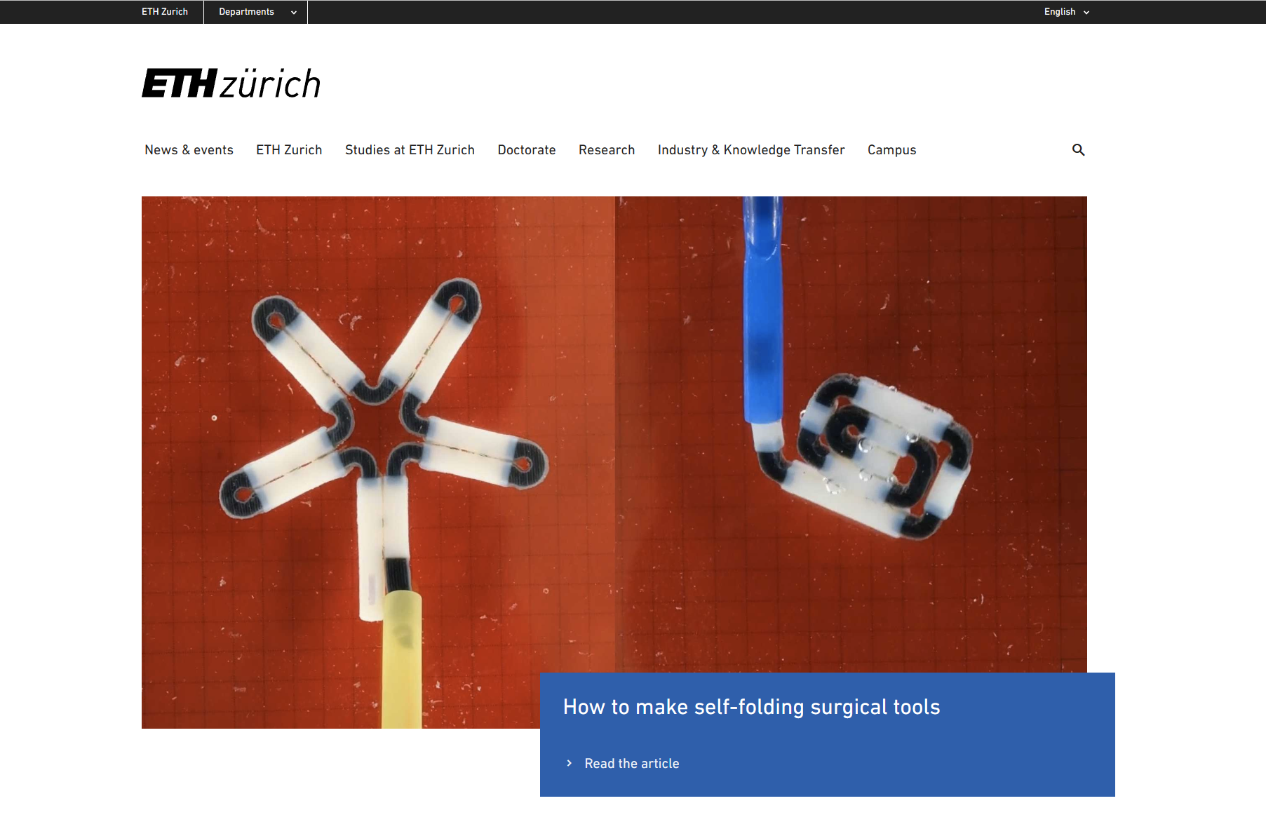

Major Scientific Achievement 2: World’s smallest robust microrobotic delivery method

Microrobots can deliver drug molecules to targeted tissues, minimizing overall side effects. Existing mobile microrobots have relatively low speeds, and it is difficult to swim against the complex fluid flows inside the human body. We have developed a robust microrobot delivery method (Nat. Mach. Intell. 2022) that overcomes these challenges and provides rapid transport of microparticles without the need for an enclosing lumen to hold the particles together - just as kinesins walk along microtubules, the microcargoes actively walk out along a thin filament via micropatterned magnetic stepping stones. The strong magnetic field gradient in the vicinity of the micromagnets allows for strong dynamic anchoring and propulsion along the artificial microtubules at unprecedented speeds. The microrobots can even propel against strong fluid flows, which we quantified with detailed experiments and theoretical modeling. Finally, we have demonstrated that this technology is capable of precisely delivering numerous microparticles at very high concentrations to a specific location within a branching microfluidic channel network (Device, 2024). This technology takes a large step forward from science fiction to real-world applications.
This research was presented at microTAS 2022, where it won the Best Talk Award (runner-up) and was widely covered in the media, including a 'News and Views' article on Nature Machine Intelligence.

Representative papers:
[1] Hongri Gu, et al. “Scalable high-throughput microfluidic separation of magnetic microparticles”, Device, 100403 (2024). https://doi.org/10.1016/j.device.2024.100403
[2] Hongri Gu, et al. “Artificial microtubules for fast and collective transport of magnetic microcargoes”, Nature Machine Intelligence, 4, 678–684 (2022). https://doi.org/10.1038/s42256-022-00510-7

Contribution:
conceived the idea, managed the research, performed the experiments, developed the theoretical model, performed data analysis, wrote the paper

Recognition:
- Best Talk Award at microTAS 2022 (runner up), (500 USD), Chemical and Biological Microsystems
Society (CBMS)
- University of Pennsylvania homepage cover: “Inspired by nature, artificial microtubules can work against a current to transport tiny cargoes” (21.07.2022)
- News and views article in Nature Machine Intelligence: "Delivering microcargo with artificial microtubules" by Gerhard Gompper (4, 663–664, 2022)
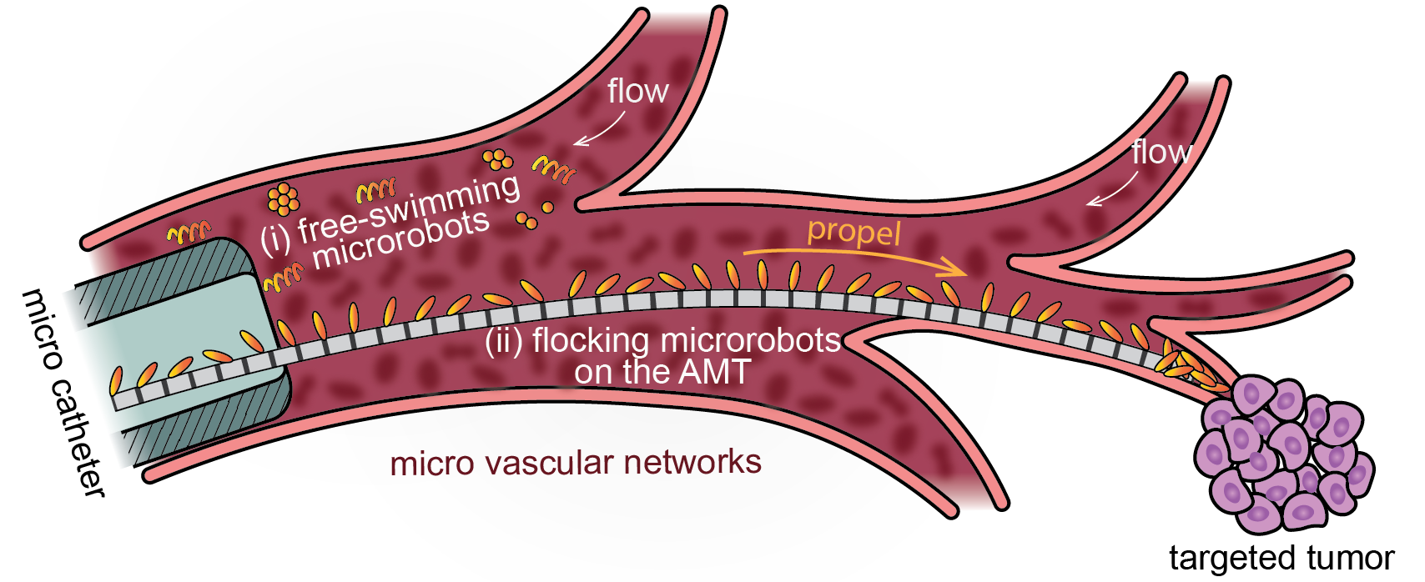

Major Scientific Achievement 3: Magnetic cilia carpets with programmable metachronal waves

As the oldest microactuator, cilia are ubiquitous in nature. We have developed a highly customizable soft robotic system for cilia research (Nat. Commun. 2020). Unlike existing artificial cilia, we provide a simple method for fabricating hundreds of customized magnetic cilia with programmable metachronal waves. This level of system integration and complexity has only been possible through computer simulation. To demonstrate the power of this soft robotic platform, we experimentally confirm for the first time two important numerical findings about fluid transport on ciliated carpets. Furthermore, inspired by the giant African millipede, we show that metachronal waves can propel a soft robot. This robotic platform provides a powerful tool to make new discoveries in basic cilia research and to inspire new soft robot designs for biomedical applications.

Representative papers:
[1] Hongri Gu, et al. “Magnetic Cilia Carpets with Programmable Metachronal Waves” Nature Communications 11, 2637 (2020). https://doi.org/10.1038/s41467-020-16458-4

Contribution:
conceived the idea, managed the research, performed the experiments, performed data analysis, and wrote the paper.

Recognition:
- ESI highly cited papers in physics
- Nature Communications’s top 50 physics articles in 2020.
- ETH homepage coverage: “Walking like a millipede” (09.06.2020)

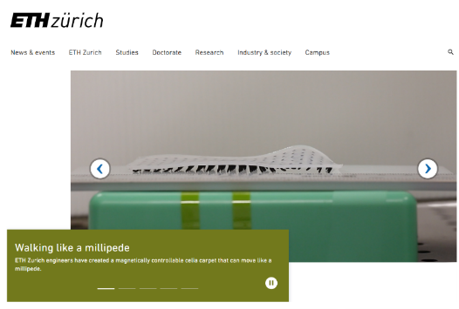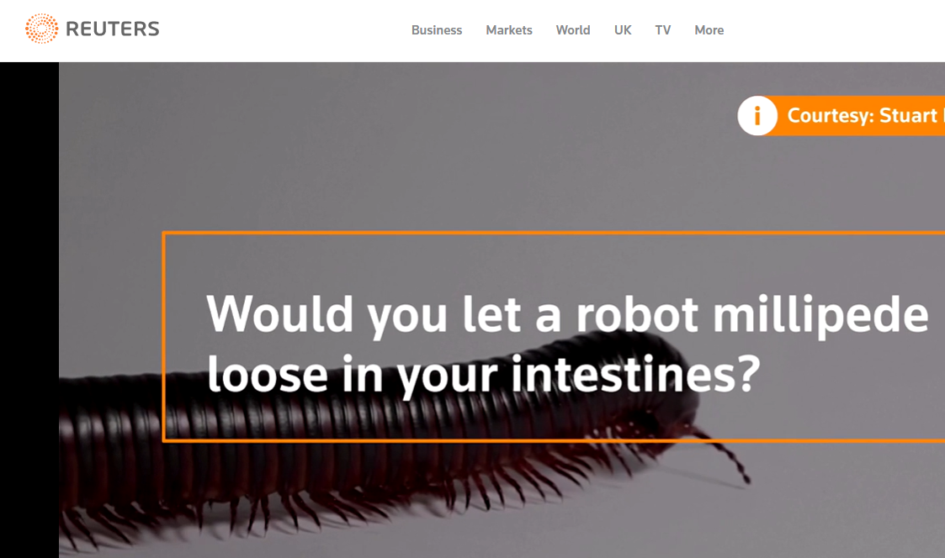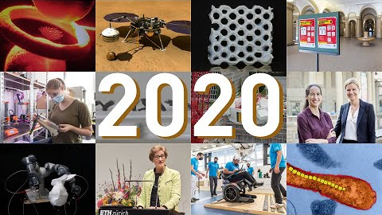

Major Scientific Achievement 4: Introducing AI to individually controlled microrobotic swarm

Just like swarms of ants can transport a large and heavy object, collective functions and cooperation among individuals have been at the core in the field of swarm robotics (e.g., Kilobots, wheeled robots, fish robots). In this work (Sci. Rob. 2024), we bring individually controlled swarm robots to the micrometer scale by using laser-driven self-propelled colloidal particles. By taking advantage of a counterfactual rewarding scheme during multi-agent reinforcement learning, we are able to assign individual rewards to each microrobot working together. This enables the effective training of an artificial neural network to perform complex collective tasks, including transport of a large rod to an arbitrary position and orientation. We demonstrate through simulation and experiments that the system is flexible, versatile, robust to strong thermal and environmental noise, robust to malfunctioning units, and can be easily adapted for many tasks and applications. This work presents a major breakthrough at the intersection of swarm robotics, microrobotics, and reinforcement learning.

Representative papers:
[1] Veit-Lorenz Heuthe, Emanuele Panizon, Hongri Gu*, Clemens Bechinger*, “Counterfactual reward enables collective transport using individually controlled swarm microrobots”, Science Robotics, 9,97 (2024): eado5888 https://doi.org/10.1126/scirobotics.ado5888

Contribution:
Supervised the project, participated in the discussion of the results, analyzed the data, and wrote the paper

Recognition:
- University of Konstanz homepage coverage: Microrobots and the “lazy agent problem” (09.06.2020)
- MIT Tech Review China coverage

